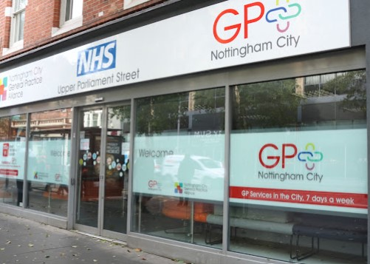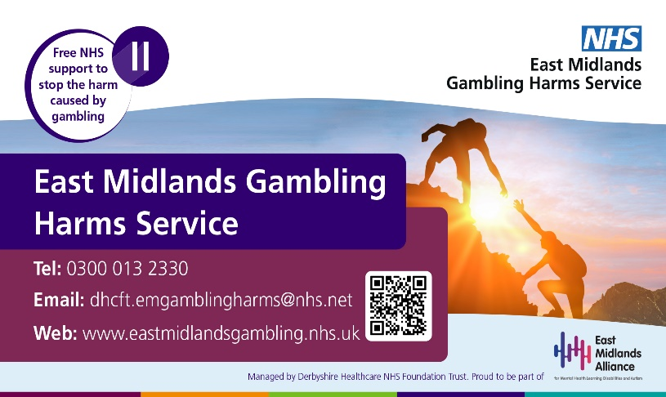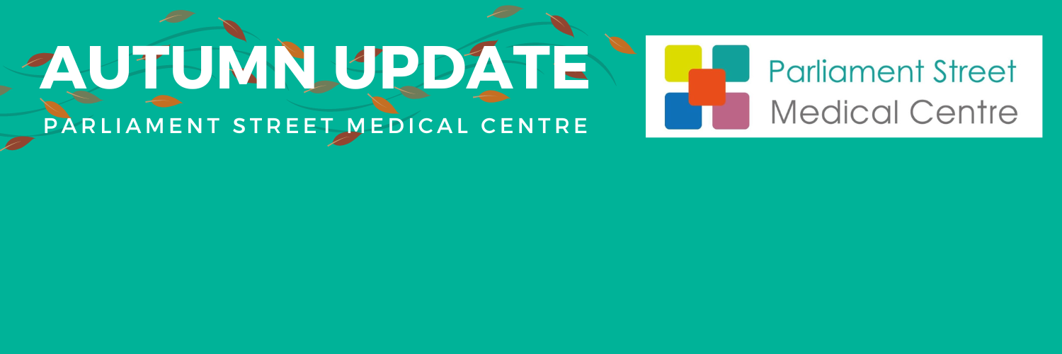

CLOSED for staff training:

**Tuesday 26 September from 12pm**

**Tuesday 17 October from 12pm**

**Opening hours:**

Monday: **8am – 6.30pm**

Tuesday: **7.30am – 6.30pm**

Wednesday: **7.30am – 7pm**

Thursday: **7.30am – 6.30pm**

Friday: **7.30am – 6.30pm**

Saturday – Sunday: **CLOSED**

**East Midlands Gambling Harms Service**

Has your gambling become more of a problem than a pleasure? A new NHS service is offering free support across the East Midlands.

Their team of psychologists, therapists, mental health practitioners and psychiatrists can help you manage your gambling issues through face-to-face or virtual sessions.

**Flu and Covid Vaccinations**

As we head into the winter months, certain groups of people will soon be offered their yearly flu vaccinations to help protect them from illness.

If you are eligible for either vaccine you will be contacted by the practice. Those being offered a flu vaccine include:

* Residents, carers, or staff working in a care home for older adults
* All adults aged 65 years or over
* Frontline health and social care workers
* People with weakened immune systems (or living with them)

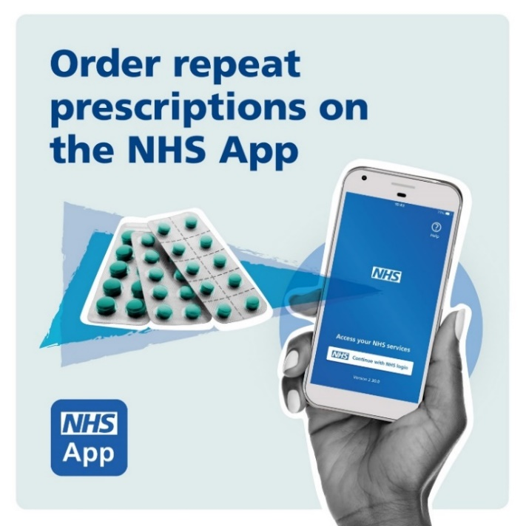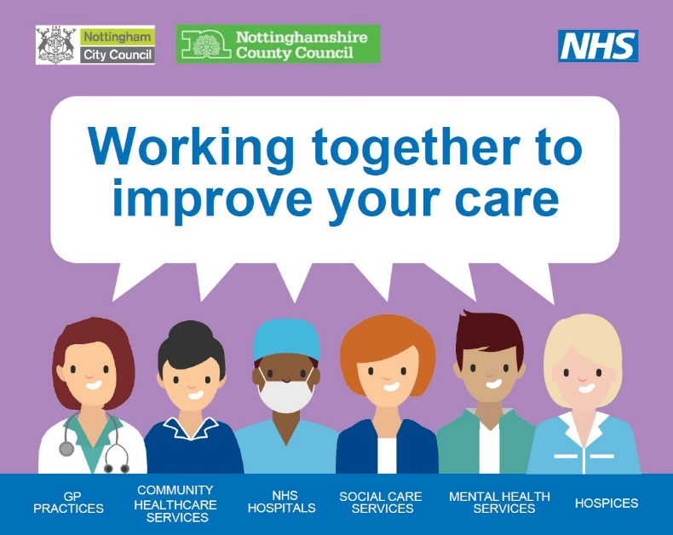

**We Want to Hear from You**

Your feedback is incredibly important to us. We want to hear your thoughts on what we are doing well, what we could improve, and how likely you would be to recommend the practice to friends and family.

***Currently,89% of our patients would recommend the practice to friends or family.***

If you have feedback you would like to leave, you can fill out the form on our website homepage. Alternatively, you can ask at reception for a printed copy of the form.

**Prescriptions**

Did you know that as well as in person, you can request prescriptions through email and the NHS app?

This means you do not have to contact the practice directly to make prescription requests.

Please allow 48 - 72 hours for your prescription request to come through.

**Notts Care Record**

The practice uses Notts Care Record.

By sharing patient data across services, clinical and care staff involved in your care can access relevant medical information to improve your care.

To opt-out, please speak to reception.

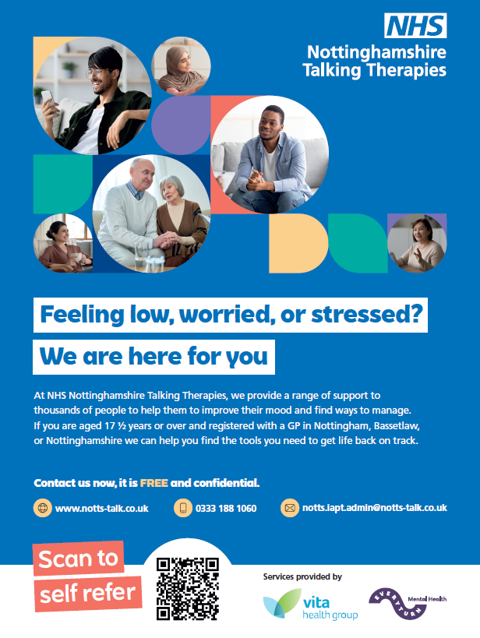

**Talking Therapy**

NHS Nottingham Talking Therapies provide a FREE and confidential service for adults registered to a GP in Nottingham.

They provide a range of evidence-based talking therapies and new ways of coping, tools, and resources to help you manage your mood.

All therapies can be provided via secure video, text-based therapy, webinar, phone, or in-person.

**Tel:** 0333 188 1060 **Email:** [notts.iapt.admin@notts-talk.co.uk](mailto:notts.iapt.admin@notts-talk.co.uk) **Web:** www.notts-talk.co.uk

**Nottingham Central Women’s Aid**

A range of FREE programmes from Nottingham Central Women’s Aid are now available:

* **The Freedom Programme** (12-week domestic abuse programme)
* **Own My Life** (12-week empowerment programme)
* **Power of Change** (12-week recovery programme)

Sessions will explore the tactics of an abuser, beliefs of abusive people and how women can recover and regain ownership of their lives, including owning their mind, body, choices, relationships, world, and feelings.

Sessions are held weekly in Sherwood with childcare and refreshments provided. To book your place, text or call the team on **07856 638 26**.

